Terahertz Spectroscopy Measurements on Black Silicon
by
Jesper Graungaard Bertelsen
AU-ID: au689481, Study-ID: 202204617

Bachelor’s Thesis
in
Electrical Engineering

Supervisor:
Pernille Klarskov

Co-Supervisor:
Rasmus Davidsen

Aarhus University, Department of Electrical and Computer Engineering
<date of submission, e.g. 5 December 2025>

Indholdsfortegnelse
Abstract 3
Introduction 3
Eksperimental setup 3
Verifying the setup 4
Methods and theory 5
Black sillicium 5
Terahertz Time-domain Spectroscopy ( THz-TDS ) 5
Usikkerhedsberegninger 6
Experimental results 7
Discussion 8
Future work 8
Conclusions 8
References 8
Bibliografi 8

Opstilling taget fra eksempel:
- Abstract
- Introduction
- Literature Review
- Methodology
- Analysis and Discussion
- Future Work
- Conclusions
- References

Abstract

Introduction

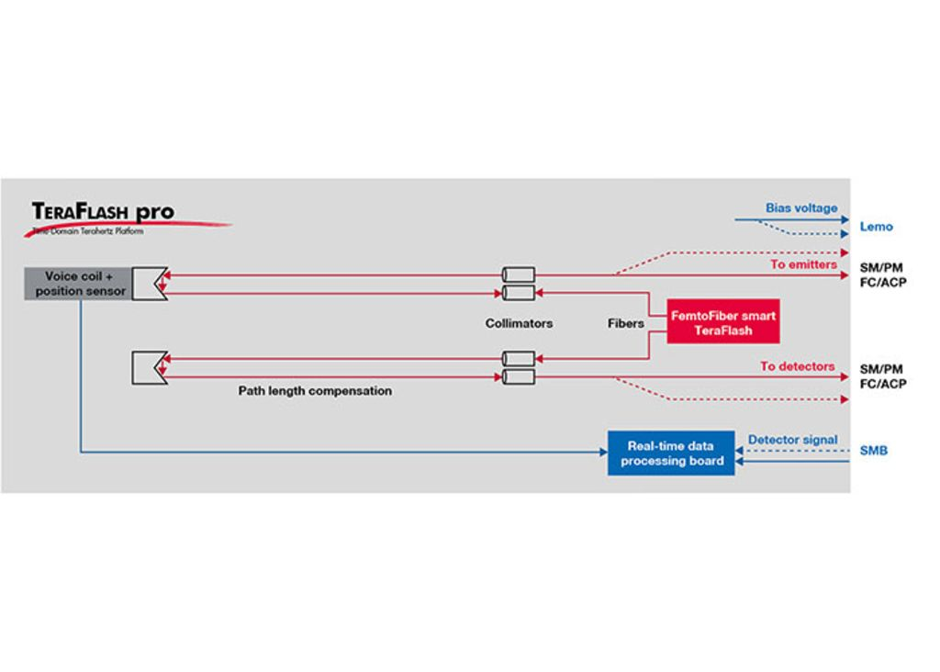
Eksperimental setup
Grej til rådighed, TeraFlash Proen af toptica.
Bord hvor man kan skrue ting fast på. Apperaturer til at holde spejle på plads og ellers justere højden for mediummet.
Grejet fra toptica bruger en FemtoFiber Smart TeraFlash laser,
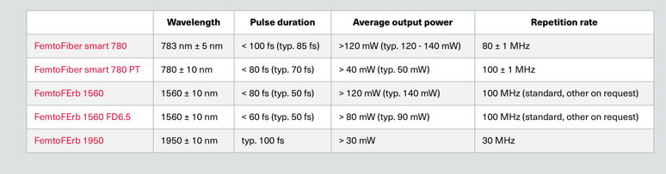
https://www.toptica.com/products/ps-fs-fiber-lasers/femtofiber-smart
På deres hjemmeside har de to kandidater som hedder noget lignende. Time steppet efter sampling afslører, at det er en 0,05ps = 50fs pulse. Dermed er det enten
FemtoFErb 1560 eller FemtoFErb 1560 FD6,5.

Verifying the setup
When having set it all up, we then want to verify, that all is working accordingly. This ensures, that the values I’ll later get can be interpreted correct. For what I’ll be using THz TDS for, it’s to describe etching of the black sillicon reference material. The refractive index of Si is well known and with the depth being known aswell, we should see the refractive index convergerging towards the refractive constant.
Using a change in refractive index of two mediums and taking that in terms of how it affects the change in phase, one can derive an expression for a uniform material to be:
$$n_{si}=\left|∆ϕ\right|·\frac{c}{ω·d}+n_{0} ⋆1$$
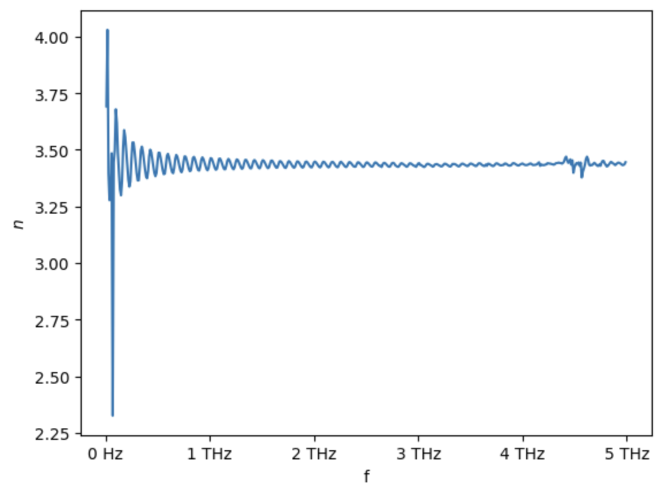
Which we can use for analysis in the frequency domain. [1]
Figure 1: The refractive index of Si varying over frequencies

Due to singularities for $\lim_{ω→0}{n_{si}\left(ω\right)}$ there is methods for overcoming that, making a new refractive index using what’s known as Phase Extrapolation
$$n_{si}^{'}\left(ω\right)=n_{si}\left(ω\right)+m·2π\frac{c}{ωd} ⋆2$$
For m being an arbitrary integer, that ensures, that the best results is seen around $ω=0$. [2]
For my reference sample, $m=0$ made for the best result, meaning that phase extrapolation didn’t help.
Then drawing conclusions from the figure, I saw my refractive index converging towards an approximate of $n_{si}≈3,43$, which are a value of the refractive index one could expect. Having gotten that verification made me able to move on towards new steps.

Methods and theory

Black sillicium
Med dens lave reflektivitet, så er black sillicium et godt materiale når det kommer til at inkapsle solens stråler, som er essencen i en solcelle…
Jeg ved ikke meget om det, men vil give det lidt tid, og prøve at få lidt teori om det indover også.

Terahertz Time-domain Spectroscopy ( THz-TDS )
Hvad? Generalle idé bag.
Hvorfor THz?
”The spectral range between 0.1 THz and 10 THz ( $3,3cm^{-1}-333cm^{-1}$ ) is an important region for low frequency dielectric relaxation and vibrational spectroscopy of liquids, such as water, methanol, ethanol, propanol, and others” [3]. It’s due to properties within molecules and material science and more that motivates us to make analytics in these frequency spectra.
( THz begyndelsen? )
…
It has since been implemented in many field of studies ( Kilde ? ).
Usually one buys these tools premade by companies such as ( Hvad hedder de nu? Link til kassen ), but within the box a lot is happening.

The generation ( PCA )
For THz generation one can use a more industrial common laser in the fs range. That will give the THz radiation a duration in the ps range, and can have simplifying properties, when it comes to the detection [4] of the THz field. There exist several techniques of creating THz radiation. For my setup, PCA was the chosen one.
PCA stands for photo conductive antenna, and as the name suggest, a photon excites an antenna which makes it more conductive, resulting in a current flow. In THz - TDs the electric field becomes a function taking this current as a variable. In PCA two metal plates are put in parallel to one another. That can be done by lithografically fabricating it on a semiconductor, and biasing it with a bias voltage, that is insufficent for current flowing to. The bias should however be sufficient for the current to flow, when the laser of choice pumps it between the plates. The THz field can then be described as a function of time
$$E_{THz}\left(t\right)∝w_{0}·\frac{\sin\left(α\right)}{r}·\frac{d}{dt_{r}}·\left(I_{PC}\left(t_{r}\right)\right)$$
$α$ is the angle of observation, $w_{0}$ is a diameter of the metal plates and $t_{r}$ is the retarded time, being the time variable time shifted by the time it takes for light to occur at the observer $t_{r}=t-\frac{r}{c}$ [4]. By this relationship we can tell, that the THz field is a function of the change in current across the metal plates. We can also tell, that the THz field is highly divergent by the $\sin\left(α\right)$ faktor, being at min and max values at $±90°$. This is something to take into consideration when setting up the THz - TDS station.
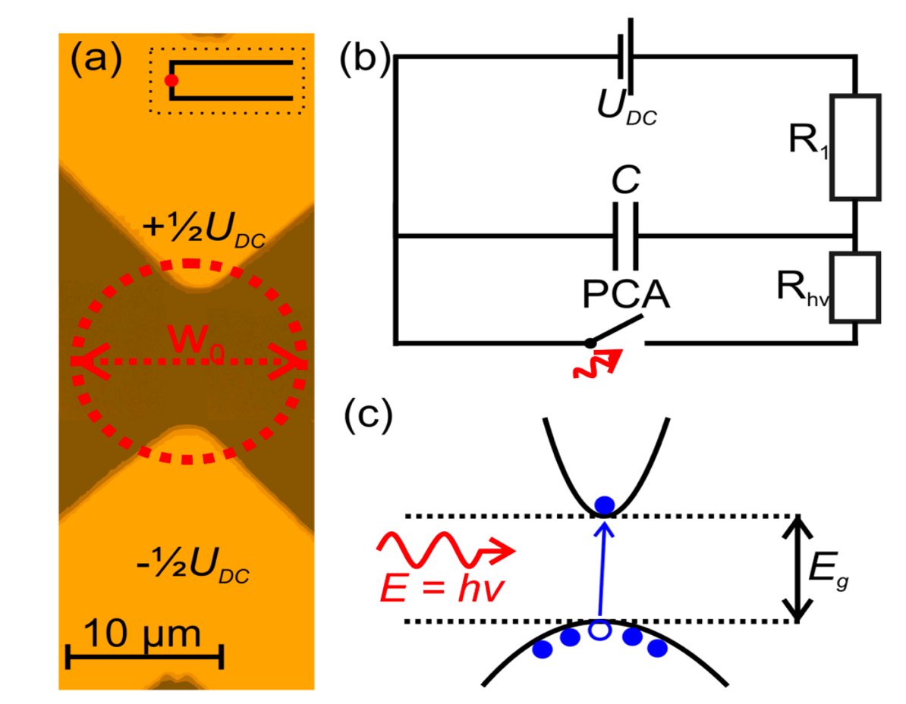

Figure 2: Figure taken from the tutorial of J. Neu and Charles. A. Schmuttenmaer:
(a) Optical microscope image of a dipole photoconductive antenna (PCA). The laser spot is focused in the gap, while a bias voltage is applied between the metallic contacts. Inset: overview of a simplified antenna, the red dashed circle indicates the location of the laser illumination. (b) Simplified electrical circuit diagram illustrating the basic concept of the photoconductive switch. (c) Simplified band scheme illustrating the photoexcitation by a photon with $E=hv>E_{g}$ i.e., larger than the bandgap.

For the case of a femtosecond laser pulse the duration of the THz field will be in the range of picoseconds [4].

The detection ( PCA )
As with the generation of THz fields, the detection has different ways of retrieving the same results as well [5]. In my setup, the equipment uses PCA for the detection.
For the detection of the THz field using PCAs, similar setups to the generation of the THz fields can be used. However instead of biasing the circuit, the emitted THz field at the generation site, should have equal energy as the required energy at the output site [6]. That is, if we’ve succeded in focusing the light, such that everything at the emitter enters the detector. It’s also an assumption, that no loss occurs along the way. A practical design should then take those things into account.

As described in the tutorial of Jens Neu and Charles A. Schmuttenmaer, the femtosecond laser will result in a change of current in the femtosecond range, but the emitted THz field will be in the picosecond range. As the laser within my equipment is also in the femtosecond range, this holds for my setup as well [7].
Issues arives when trying to sample such small time intervals using conventional electronics. Electrical signals has rise and fall times in the regions of nanoseconds. Requiring picoseconds resolution then means, that conventional electronics doesn’t have what it takes to sample useful information. Instead of the electronics having to sample faster than it’s able to, we tend to optics to solve the requirement of picosecond resolution.
At a given time, the signal can be described as:
$$S\left(t\right)∝I_{opt}\left(t\right)·E_{THz}\left(t\right)$$
As conventional detectors are to slow, our solution is then to tend to another relationship:
$$S\left(t_{1}\right)∝I_{opt}\left(t_{1}\right)⋆E_{THz}\left(t\right)$$
Where $E_{THz}\left(t\right)$ comes from the generation side, and the $I_{opt}$ comes from the intensity of the input laser. By convolution we get a relationship towards a message at a given time. Due to the duration of the laser is in fs and the duration of the THz field being in ps, the optical intensity would act as an weighted impulse. If we only care about the proportionality we can say that:
$$S\left(t_{1}\right)∝I_{opt}\left(t_{1}\right)⋆E_{THz}\left(t\right)≈δ\left(t_{1}\right)⋆E_{THz}\left(t\right)$$
$$S\left(t_{1}\right)∝E_{THz}\left(t_{1}\right)$$
That gives us a relationship, that we can use for sampling [7].

At a set time $t_{1}$, we will get the information corresponding to the electric field at $t_{1}$. A timeshift of the input laser can then result in information about different points on the electric field.
As
$$s=t·c$$
For s being the path length, c the speed of light, we have a relationship between distance required as a function of time resolution required.
For a laser in the femtosecond region resulting in picosecond THz radiations, the lengths required to achieve those resolutions are in the millimeter range. That makes it sensible to small ranges, and computer-controlled position stages can be used to fulfill those requirements. [7]

Possible issues
Snak om termisk støj og tidsforskydning.
Sample and hold som virker som et lavpass filter.

We can then say that.

and a beam split from the laser is being convoluted by it,
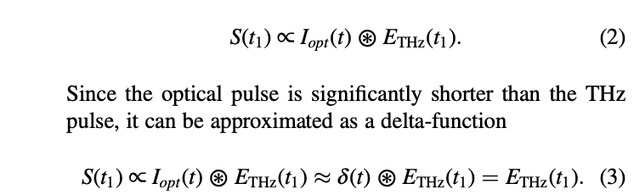

instead we sample at a set time for every pulse, but every pulse.

and delaying the signal

That makes information being sampled in the picosecond range have noise from the transitions. As well as the information may never

meaning that an information is being sampled a lot of times before the transitioning between information has occurred. As well as the way trans

making information sampled in the picosecond range include sampling in the picoseconds include information that’s about to become. The

Such small time intervals to sample using conventional electronics.

Snak om rise time og fall time af elektroniske signaler. Hvordan det er blevet overkommet vha. optik i stedet for.
Kilde

.
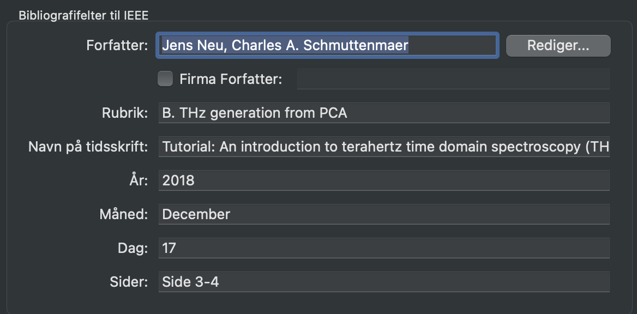

The region of THz is a useful spectral area for some physical properties of molecules
THz optiske egenskaber.
fs - laser ( Overgang )
THz - TDS intro.

Terahertz Time-domain Spectroscopy or THz - TDS is an optical measurement tool, used within a wide range of academic fields. From the application in medical field, where it has been shown to detect skin cancer, to the field of security and more [3].

Within the field of material science, it’s also being used as an alternative method to conventional methods of using electronics.
Traditional methods within electronics are limited by the rise and falling edge of signals. As signals aren’t instantaneously, information can become redundant when trying to sampling at too high of sampling speeds. To obtain the THz benefits in the scientific field of use, one would have to sample in picosecond resolutions, as the electric fields seen at a detector usually don’t last longer. With rise times in picoseconds, information about what’s the signal and what’s the rise and fall of the signal becomes blurred [4]. With optics we unlock new possible tools for sampling.

[5]

Traditionelle elektroniske metoder er begrænset af sampling speeden. ADC bruger zero-order hold eller andre metoder, men som med elektronik, så er de metoder begrænset af rise og fall time. Hvis følgende ikke gælder, at $s\left(t\right)≫r\left(t\right)∩f\left(t\right)$ så betyder de samplede informationer ikke meget. I metoder hvor man har brug for meget stor tids resolution, så er der derfor ikke hjælp at hente på den traditionelle måde gennem elektronikken.
Da må man finde andre metoder. Optik har ikke samme begrænsninger som elektronikken, så en metode ved brug af det kunne give muligheder…
Det elektriske felt ved detektor varer typisk kun få picosekunder. Den traditionelle elektronik har rise og fall time i netop picosekunder. Det giver derfor ikke mening, at bruge de metoder til at sample nyttig information
Optik trin. Hvordan samples der?
Ved brug af convolution. Signalet kan beskrives propoere med $S\left(t\right)∝I_{opt}\left(t\right)E_{THz}\left(t\right)$ som er den øjeblikkelige værdi. Hvis man forskyder tiden, så kan beskrive det ved konvolution:
$S\left(t_{1}\right)∝I_{opt}\left(t\right)⋆E_{THz}\left(t_{1}\right)$
Med optikkens intensitet kommende fra en puls, som er noget kortere end terahertz feltets signal, så kan den næsten ses som en impuls. Konvolution med en impuls er signalet tidsforskudt til impulsens tid.

Hvorfor? ( Motivation, Egenskaber & fordele )
Hvordan?
- Generering?
- Detector side?
- Sampling? Optisk tids resolution.
- Problemer? Water vapor
- Signal behandling? Vindue

Hvorfor ikke? ( Ulemper, dyrt og ikke industriklart )

Terahertz Time-domain Spectroscopy ( THz-TDS ) Gammel
Terahertz Time-domain Spectroscopy is an optical measurement tool, used within a wide range of academic fields. From the application in medical field, where it has been shown to detect skin cancer, to the field of security and more [3]. Within the field of material science, it’s also being used as an alternative method to conventional methods of using electronics.
Terahertz? Hvorfor? Hvad er motivationen bag?
Transparency range SI ( 1,2um til 9um)
$v=λ·f, f=\frac{c}{λ}$
$c≔3·{10}^{8}\frac{m}{s}$
$$f=\left\{\begin{aligned}\frac{c}{9·{10}^{-6}m} \\ \frac{c}{1,2·{10}^{-6}m}\end{aligned}\right\}=\left\{\begin{aligned}33,3\overline{3} \\ 250\end{aligned}\right\}\left[THz\right]$$
Så terahertz er blandt andet nyttig til at infiltrere i Si.

Terahertz TDS? Motivationen bag?
Terahertz TDS? Hvordan?

Tutorial: An introduction to terahertz time domain spectroscopy (THz-TDS), alt hvad der står I den:
“Terahertz time-domain spectroscopy (THz-TDS… It has been used for contact-free conductivity measurements of metals, semiconductors, 2D materials, and superconductors. Furthermore, THz-TDS has been used to identify chemical components such as amino acids, peptides, pharmaceuticals, and explosives, which makes it particularly valuable for fundamental science, security, and medical applications”
- INTRODUCTION

“There are also applications where THz-TDS is being optimized for the detection of bombs, drugs, and weapons”
“In the field of materials science, THz-TDS is ideally suited to measure mobile charge carriers since they reflect and absorb THz radiation”
“The interest in THz-TDS from the medical community has been growing in recent years. Proof-of-concept experiments are able to detect skin cancer”

Terahertz? Hvad er motivationen bag.
Terahertz vides at have nogle egenskaber i de forskellige akademiske felter. Hvad vil det kræve? Traditionel består? Optik kun?

Terahertz TDS? Motivationen bag:
Traditionelle elektroniske metoder er begrænset af sampling speeden. ADC bruger zero-order hold eller andre metoder, men som med elektronik, så er de metoder begrænset af rise og fall time. Hvis følgende ikke gælder, at $s\left(t\right)≫r\left(t\right)∩f\left(t\right)$ så betyder de samplede informationer ikke meget. I metoder hvor man har brug for meget stor tids resolution, så er der derfor ikke hjælp at hente på den traditionelle måde gennem elektronikken.
Da må man finde andre metoder. Optik har ikke samme begrænsninger som elektronikken, så en metode ved brug af det kunne give muligheder…
Det elektriske felt ved detektor varer typisk kun få picosekunder. Den traditionelle elektronik har rise og fall time i netop picosekunder. Det giver derfor ikke mening, at bruge de metoder til at sample nyttig information. [4]
Optik trin. Hvordan samples der?
Ved brug af convolution. Signalet kan beskrives propoere med $S\left(t\right)∝I_{opt}\left(t\right)E_{THz}\left(t\right)$ som er den øjeblikkelige værdi. Hvis man forskyder tiden, så kan beskrive det ved konvolution:
$S\left(t_{1}\right)∝I_{opt}\left(t\right)⋆E_{THz}\left(t_{1}\right)$
Med optikkens intensitet kommende fra en puls, som er noget kortere end terahertz feltets signal, så kan den næsten ses som en impuls. Konvolution med en impuls er signalet tidsforskudt til impulsens tid.
Hvorfor vi implementerer delay lines.

Hvordan laves det elektriske THz felt? ( PCA )
$E_{THz}\left(t\right)∝w_{0}·\frac{\sin\left(α\right)}{r}·\frac{d}{dt_{r}}\left(\left|I_{PC}\left(t_{r}\right)\right|\right)$ $\left(6\right)$
r er afstanden og og $α$ er vinklen, som man observerer terahertz feltet fra. $t_{r}$ er den retarderede tid, $I_{PC}\left(t_{r}\right)$ er strømmen i photoconducteren. [8]
Jo egentlig simpel. Du biaser dit kredsløb med en bias voltage, som passer med, at din laser kilde vil få strøm til at løbe igennem de to plader som virker som kondensatorer.
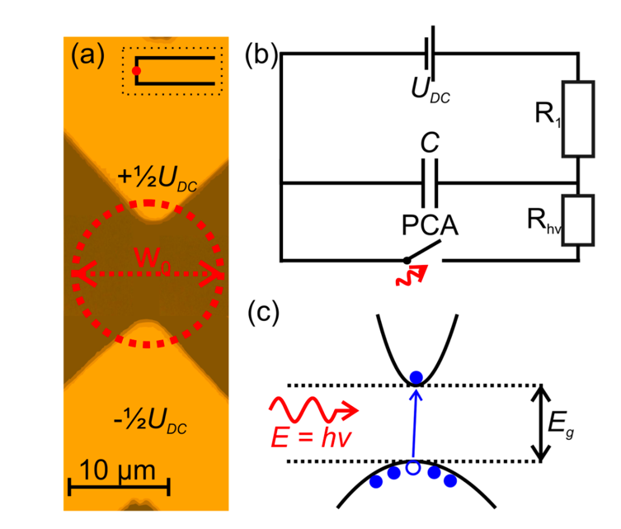

Hvordan opfanges det elektriske THz felt? ( PCA )
“THz detection via photoconductive switches can be performed with similar or even identical devices as used for THz generation. In contrast to generation, the metal gap fabricated on the semiconductor is not externally biased” [9] <- Giver mening. Uden tab burde det exciterede photon.fra generatoren være lig med bandgappet ved receiveren.

Carrier lifetime ved receiveren er i ordnen 100-300 fs og laver strømme af ordnen nA.
Det er nogle stærke krav til systemet, hvor at termisk støj kan beskrives som
$U_{noise}=\sqrt{\frac{k_{B}T}{C}}$
Hvor kapacitansen kan beskrives som $C≈10fF$. Da vil der gælde ved en stuetemperatur på 295 Kelvin. :

$$Definer: k=1,3806504·{10}^{-23}J·K^{-1}$$
$$U_{noise}=\sqrt{k·\frac{295K}{10·{10}^{-15}F}}≈650μV$$
Resistancen af antennaen kan siges at have en størrelse på 1MΩ. Da vil strømmen påført af strøm være i ordnen.
$$I=\frac{650·{10}^{-6}V}{1·{10}^{6}Ω}=650nA$$
Da vil støjen være på samme niveau som signalet, og derfor er det triggy at skelne mellem de to. [9]

Filter.

Flow chartet.

- CONCEPT OF TIME-DOMAIN SPECTROSCOPY (TDS)
“The THz electric field at the detector is typically on the order of 10–100 V/cm65 and has a time duration of a few picoseconds” <- Krav
Direct electrical detectors and circuits usually have rise times and fall times in the picosecond to nanosecond range and, therefore, do not have high enough time resolution. <- Konventionelle metoder
The way to reach sub-picosecond resolution is by using optical techniques wherein an ultrashort NIR optical pulse (typically shorter than 100 fs) is beamsplit along two paths to generate and detect the timedependent THz field. Measuring in the time-domain is based on sampling the
unknown THz eld with a known femtosecond laser pulse, which is referred to as the read-out pulse. THz-TDS uses the
convolution of a short read-out pulse with the longer THz pulse <- Hvordan så?

$S\left(t\right)∝I_{opt}\left(t\right)E_{THz}\left(t\right)$ $\left(1\right)$
”All existing detectors are too slow, so the convolution $⋆$ of the two pulses is measured instead”
$S\left(t_{1}\right)∝I_{opt}\left(t\right)⋆E_{THZ}\left(t_{1}\right)$ $\left(2\right)$
“Since the optical pulse is significantly shorter than the THz pulse, it can be approximated as a delta-function”
$S\left(t_{1}\right)∝I_{opt}\left(t\right)⋆E_{THZ}\left(t_{1}\right)≈δ\left(t\right)⋆E_{THz}\left(t_{1}\right)=E_{THz}\left(t_{1}\right)$
Så hvad? Fordi at den konventionelle metode for at beregne signalet i
det digitale ikke har tilstrækkeligt tidsresolution, så kan vi ikke måle det.
Derfor tyder vi til det optiske, hvor vi kan bruge egenskaberne af konvolution. Bemærk, at her ser vi på det elektriske felt til en valgt tid. Noget som ser uendeligt småt ud i konvolution kan ses som et impuls. Konvolution med et impuls giver den samme, bare tidsforskudt til impulsens tid. Med reference i impulsen, så vil den ikke blive forflyttet.
”…we measure the timedependent amplitude E(t), in contrast to other techniques such as FTIR which measure only the intensity [E2(t)] of an electromagnetic signal and, therefore, do not capture the phase information” <- Hvorfor THz-TDS er interesant.
“The measured signal corresponds to the THz eld amplitude at a single point in time (t1). The next step is to measure the signal at all time-points”

Hvad jeg snakkede om med feltet til en enkelt tid.
“The travel time of a laser pulse is t = s/c, where s is the path length and c is the speed of light (this corresponds to 30 cm/ns or 300 μm/ps)”
“Precise micro positioning is achieved with computer-controlled positioning stages”
“The round trip delay time changes 6.6 fs for each micrometer of delay line displacement”

$t=\frac{d}{v}$
$v=\frac{d}{t}≈\frac{300μm}{ps}$
$t\left(d\right)≔\frac{d}{\frac{300μm}{ps}}$
$t\left(1μm\right)=3,33333·{10}^{-15} s$
Jeg får godt nok 3,3fs som mit resultat. Men det er vidst ligegyldigt.
“Water vapor has strong absorption features in the THz range that can interfere with measurements.66,67 To minimize this absorption, the THz beam path is enclosed in a purge box (see Fig. 1)” <- Taler til usikkerheden ved metoden.
$$Slet definitioner:$$

Water vapor ( Noise )
Et vand molekyle er bundet sammen med:
Vand molekylet er bygget om med oxygen som har 2 elektroner i dets indre skal og 6 elektroner i dens ydre skal.
Så deler den med hydrogen atomerne, så den anden skal får sig 8 elektroner.
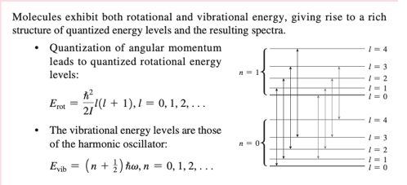
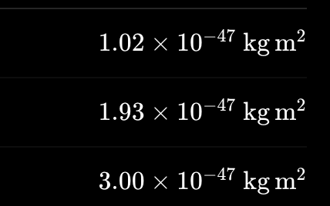
Et vandmolekyle har 3 inertimomenter.
$$E_{rot}\left(I,l\right)=\frac{{\left(\frac{h}{2π}\right)}^{2}}{2·I}·\left(l+1\right)$$
$I_{1}≔1,02·{10}^{-47} kg·m^{2}$
$I_{2}≔1,93·{10}^{-47} kg·m^{2}$
$I_{3}≔3·{10}^{-47} kg·m^{2}$
Molekylet kan have dets rotations energi skifte med 1, derfor vil jeg kunne sige, at hver overgang har samme energi, for hvert intertimoment:
$∆E_{rot}=\frac{{\left(\frac{h}{2π}\right)}^{2}}{2·I}·\left(l+1\right)-\frac{{\left(\frac{h}{2π}\right)}^{2}}{2·I}·\left(l-1+1\right)=\frac{{\left(\frac{h}{2π}\right)}^{2}}{2·I}$
$∆E_{rot1}=\frac{{\left(\frac{h}{2π}\right)}^{2}}{2·I_{1}}≈0,003403 eV$
$∆E_{rot2}=\frac{{\left(\frac{h}{2π}\right)}^{2}}{2·I_{2}}≈0,001798 eV$
$∆E_{rot3}=\frac{{\left(\frac{h}{2π}\right)}^{2}}{2·I_{3}}≈0,001157 eV$
Det spectrum vi leder efter er $\left[0,8;1,15\right]\left[THz\right]$
$E=h·0,8·{10}^{12}Hz≈0,003309 eV$
$E=h·1,15·{10}^{12}Hz≈0,004756 eV$
Det ligner jo meget den rotations energi der er.
Hvor går grænsen?
$f=\frac{E}{h}=\frac{0,003403 eV}{h}≈0,823 THz$
Så vi kigger på spektret $\left[0,8;1,15\right]\left[THz\right]$, og fra $\left[0,823;1,15\right]\left[THz\right]$ har photonet nok energi til at få vandet til at vibrere. Det viser sig altså hvorfor, at vi ønsker at filtrere vandpartiklernes påvirkning fra.
https://www.researchgate.net/figure/The-moments-of-inertia-of-a-water-molecule-around-three-different-axes-The-numbers-are_fig1_328024287
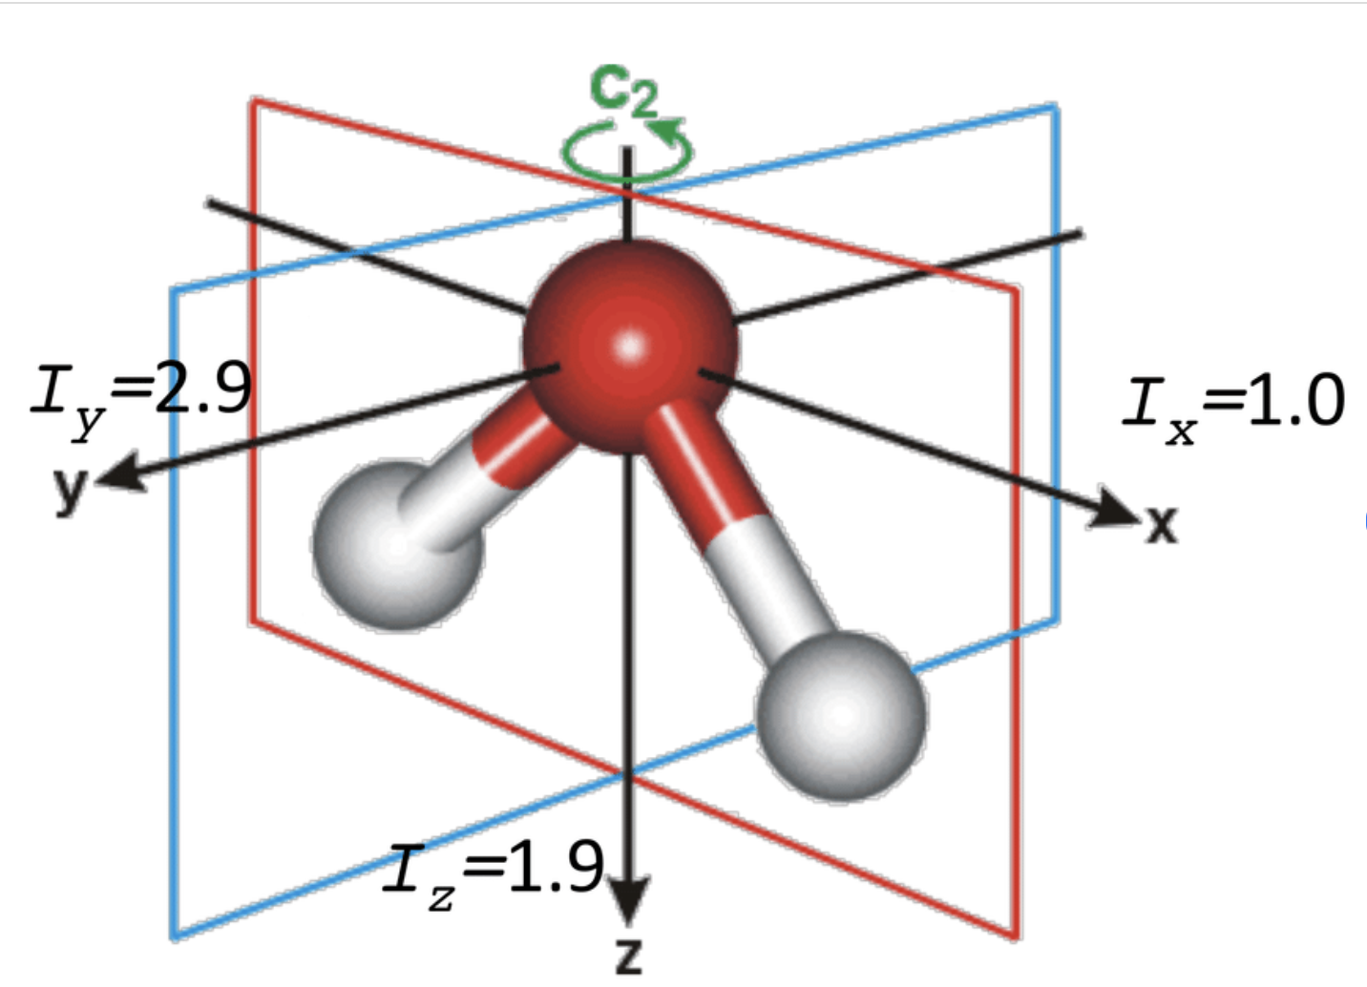
${10}^{-47}kg·m^{2}$

- THz GENERATION
- Overview on THz emitters
” The different emitters, summarized in Table I, can be categorized in two different groups based on the underlying mechanism for THz generation.”
PCA. “One way to generate THz radiation is to induce a short current pulse in a medium, which then emits THz radiation as described in detail below”
OR: The other commonly used method is via a nonlinear optical rectification process which is primarily used in amplifier based systems

“To allow a rough estimation, we labeled the different mechanisms with either oscillator (Osci.) or amplifier (amp). For the purpose of this tutorial, a laser oscillator has a repetition rate between 40 MHz and 1 GHz, a pulse length of less than 150 fs, and a pulse energy below 10 nJ. In contrast, the amplifier has a repetition rate of 1-10 kHz, with a pulse energy of more than 10 μJ and also a pulse length of less than 150 fs. Emitters and detectors typically increase in bandwidth and efficiency with shorter laser pulses.”
$$1GHz→\frac{1}{{10}^{9}}s=1ns \\ 40MHz→\frac{1}{40·{10}^{6}}s=25ns \\ 10kHz→\frac{1}{1·{10}^{4}}s=100μs \\ 1kHz→\frac{1}{1·{10}^{3}}s=1000μs$$Pulse length < 150fs, worst case = 150fs.
$t=\frac{1}{f}$, og er den tid der er i mellem hvert puls.
Oscillator:
$$\frac{t_{puls}}{t}:$$
$$\left[\frac{150fs}{25ns}, \frac{150fs}{1ns}\right]≈\left[6;150\right]·{10}^{-6} \\ \left[6;150\right]·{10}^{-6}·{10}^{2}=\left[6;150\right]·{10}^{-4}\%$$
Så for oscillatoren, så er pulse bredten mellem $\left[0,0006\%;0,015\%\right]$.

Amplifier:
$$\left[\frac{150fs}{100μs}, \frac{150fs}{1000μs}\right]≈\left[1,5;15\right]·{10}^{-9} \\ \left[1,5;15\right]·{10}^{-9}·{10}^{2}=\left[1,5;15\right]·{10}^{-7}\%$$
Så for en amplifier, så er pulsens bredde mellem $\left[0,00000015\%; 0,0000015\%\right]$ i forhold til tiden mellem pulserne. Eller på en anden måde sagt så er der
$\left[\frac{6·{10}^{-4}}{15·{10}^{-7}}; \frac{150·{10}^{-4}}{1,5·{10}^{-7}}\right]≈\left[400, 100.000\right]$gange så meget tid mellem pulserne for en amplifier, som ved en oscillator.

Og det giver vel også mening i forhold til deres formål. For en oscillator, så ønsker vi bare en del repetitioner, hvorimod en amplifier, eller forstærker, ønsker at gøre det som den beskriver, at forstærke signalet.
Et større signal betyder længere rise- og fall time, og derfor kompenserer man ved, at gøre repetitionshastigheden langsommere.

- THz generation from a PCA

<

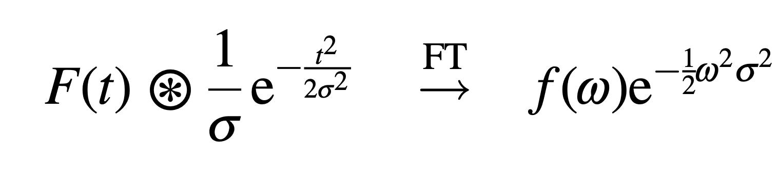
$$x\left(t\right)=\frac{1}{2π}\int_{-∞}^{+∞}{X\left(jω\right)e^{jωt}}dω$$
$$X\left(jω\right)=\int_{-∞}^{+∞}{x\left(t\right)e^{- jωt}dt}$$
$$x\left(t\right)=e^{-at^{2}}, a>0$$
$$X\left(jω\right)=\int_{-∞}^{+∞}{e^{-at^{2}}e^{- jωt}dt} \\ X\left(jω\right)=\int_{-∞}^{+∞}{e^{-at^{2}}e^{- jωt}dt}$$

$$x\left(t\right)=\frac{1}{\sqrt{2π}·σ}·e^{-\frac{1}{2}·{\left(\frac{t-μ}{σ}\right)}^{2}} \\ X\left(jω\right)=\int_{-∞}^{+∞}{\frac{1}{\sqrt{2π}·σ}·e^{-\frac{1}{2}·{\left(\frac{t-μ}{σ}\right)}^{2}}·e^{- jωt}dt} \\ X\left(jω\right)=\int_{-∞}^{+∞}{\frac{1}{\sqrt{2π}·σ}·e^{-\frac{1}{2}·{\left(\frac{t-μ}{σ}\right)}^{2}-jωt}dt} \\ X\left(jω\right)=\int_{-∞}^{+∞}{\frac{1}{\sqrt{2π}·σ}·e^{-\frac{1}{2σ^{2}}·\left(t^{2}+μ^{2}-2tμ\right)-jωt}dt} \\ X\left(jω\right)=\int_{-∞}^{+∞}{\frac{1}{\sqrt{2π}·σ}·e^{-\frac{t^{2}}{2σ^{2}}-\frac{μ^{2}}{2σ^{2}}+\frac{tμ}{σ^{2}}-jωt}dt} \\ X\left(jω\right)=\int_{-∞}^{+∞}{\frac{1}{\sqrt{2π}·σ}·e^{-t·\left(\frac{t}{2σ^{2}}+\frac{μ}{σ^{2}}+jω\right)-\frac{μ^{2}}{2σ^{2}}}dt} \\ X\left(jω\right)=\int_{-∞}^{+∞}{\frac{1}{\sqrt{2π}·σ}·e^{-t·\left(\frac{t}{2σ^{2}}+\frac{μ}{σ^{2}}+jω\right)}e^{-\frac{μ^{2}}{2σ^{2}}}dt} \\ X\left(jω\right)=\int_{-∞}^{+∞}{\frac{e^{-\frac{μ^{2}}{2σ^{2}}}}{\sqrt{2π}·σ}·{\left(e^{-\left(\frac{t}{2σ^{2}}+\frac{μ}{σ^{2}}+jω\right)}\right)}^{t}dt} \\ X\left(jω\right)=\int_{-∞}^{+∞}{\frac{e^{-\frac{μ^{2}}{2σ^{2}}}}{\sqrt{2π}·σ}·{\left(u\right)}^{t}dt} \\ u=e^{-\left(\frac{t}{2σ^{2}}+\frac{μ}{σ^{2}}+jω\right)}=e^{-\frac{t}{2σ^{2}}}e^{\left(\frac{μ}{σ^{2}}-jω\right)} \\ \frac{du}{dt}=\frac{1}{-\frac{1}{2σ^{2}}}e^{-\frac{t}{2σ^{2}}}e^{\left(\frac{μ}{σ^{2}}-jω\right)}=-e^{\left(\frac{μ}{σ^{2}}-jω\right)}2σ^{2}e^{-\frac{t}{2σ^{2}}} \\ du=-e^{\left(\frac{μ}{σ^{2}}-jω\right)}2σ^{2}e^{-\frac{t}{2σ^{2}}}dt \\ dt=\frac{du}{-e^{\left(\frac{μ}{σ^{2}}-jω\right)}2σ^{2}e^{-\frac{t}{2σ^{2}}}}$$
$$X\left(jω\right)=\int_{-∞}^{+∞}{\frac{e^{-\frac{μ^{2}}{2σ^{2}}}}{-e^{\left(\frac{μ}{σ^{2}}-jω\right)}2σ^{2}e^{-\frac{t}{2σ^{2}}}}\frac{1}{\sqrt{2π}·σ}·{\left(u\right)}^{t}du}$$

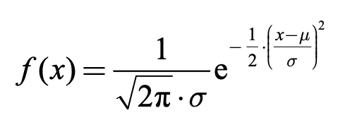
Hvis
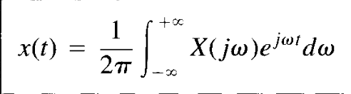
Delay lines, hvordan?

Sampling I THz TDS
Forstyrrelse af medium.
Hvorfor vi bruger [0,8; 1,15] THz på grund af at $λ_{0}≫d_{film}$, som gør det muligt at approksimere til en tyndfilmsformel. $(d_{film}≪λ_{\text{eff}})$, (
Yasiths side 12.
40. Beermann, N. S.; Gebauer, A.; Fabretti, S.; Zhang, W.; Hiraoka, T.; Achtstein, A. W.; Hafez, H. A.; Turchinovich, D. Terahertz time-domain spectroscopy for simultaneous measurement of optical constants, and material thickness with deep-subwavelength precision. Optics Express 2025, 33 (6), 8650–8660. DOI: 10.1364/OE.544182
)
0,8THz er valgt af Yasith pga, stabilitet. $λ_{min}=260,9μm=>f_{max}=1,15THz$ og $d_{film}≪λ_{min}$, så jeg kunne egentlig have valgt en vilkårlig bølgelængde højere end det. Men som sagt, 0,8THz er taget pga. stabilitet.

Usikkerhedsberegninger
Da det kan være meget svært at udlede et udtryk, hvor man simpelt kan sige, at går dette udtryk mod A, så vil mit udtryk gå mod min/max, så gik jeg videre til at bruteforce beregninger.
Operationerne
Til operationerne varierer jeg først på (dref, dsam, dfilm) til indekserne (j, k, i). Dernæst varierer jeg for alle de scans som jeg gjorde til hvert type, M = 5, med indeks m.
$avg\left\{n_{f, j, k, i}\right\}$ <- Spektret fra [0,8THz; 1,15THz]. Avg. medføre en skalar
$n_{f max}=\max_{m}{\max_{j}{\max_{k}{\max_{i}{avg\left\{n_{f, j, k, i, m}\right\}}}}}$ <- Upper bound.
$n_{f mean}=\underset{m}{avg}{\underset{j}{avg}{\underset{k}{avg}{\underset{i}{avg}{avg\left\{n_{f, j, k, i, m}\right\}}}}}$ <- Mean value.
$n_{f min}=\min_{m}{\min_{j}{\min_{k}{\min_{i}{avg\left\{n_{f, j, k, i, m}\right\}}}}}$ <- Lower bound.
Og det samme for volume fraction
${volFrac}_{ max}=\max_{m}{\max_{j}{\max_{k}{\max_{i}{avg\left\{{volFrac}_{j, k, i, m}\right\}}}}}$ <- Upper bound.
${volFrac}_{mean}=\underset{m}{avg}{\underset{j}{avg}{\underset{k}{avg}{\underset{i}{avg}{avg\left\{{volFrac}_{j, k, i, m}\right\}}}}}$ <- Mean value.
${volFrac}_{min}=\min_{m}{\min_{j}{\min_{k}{\min_{i}{avg\left\{{volFrac}_{j, k, i, m}\right\}}}}}$ <- Lower bound

Experimental results
Instead of the uniformly distributed Si wafers, these types were now the result of etching the reference substances, for them to have a layer of both air and Si.

I then need an expression, that tries to find the effective refractive index given the depth of the reference, the sample and the depth of the thin film layer.
Lines formel 5.6…

Efterfinde Yasiths resultater for typerne. Kan jeg få alle de samme resultater?
Da det var så svært at efterfinde de resultater som Yasith fik, hvor meget har usikkerhederne så påvirket det?
Usikkerheder antaget anden viden ikke haves: $d_{film}±0,5μm$, $d_{ref}, d_{sam}±20μm$ ( som anvist på deres pakker, tror jeg, at det var ).
Metode
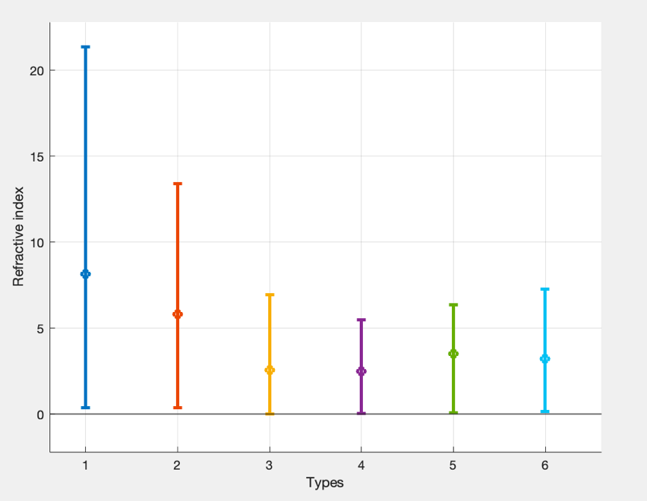
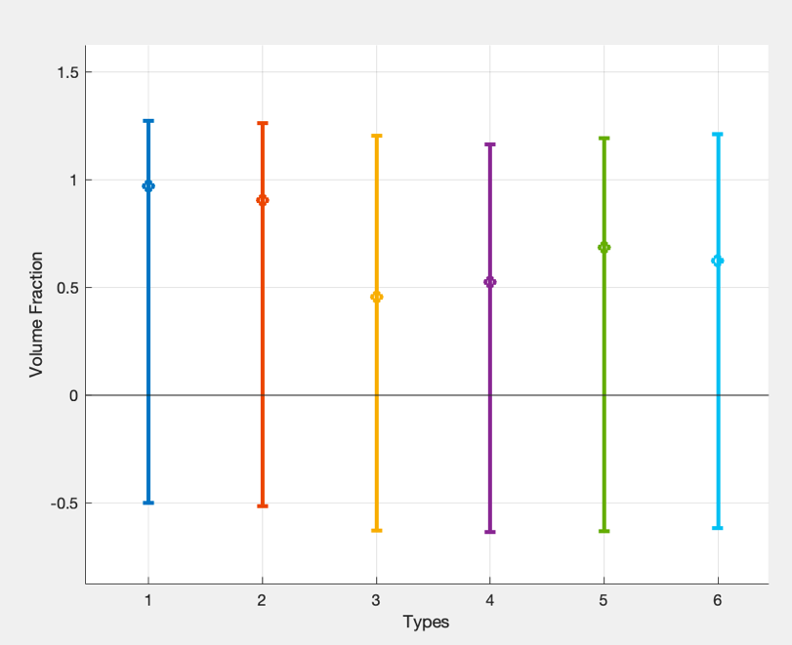
Type plot for refractive indices and volume fraction, due to uncertainties of $d_{film}±0,5μm$, $d_{ref}, d_{sam}±20μm$

Normal fordeling.

Discussion

Future work

Conclusions

References
https://www.toptica.com/products/terahertz-systems/time-domain/teraflash-pro?gad_source=1&gad_campaignid=11174164687&gbraid=0AAAAACcXkr4qej04YU3L2IcDEkUEAKXEg&gclid=Cj0KCQiAxJXJBhD_ARIsAH_JGjhTIgyeGvxpCblPZhtStP0b_JkqpdiC-K26FiAEXBBShBT-Nh_CbYQaAqNuEALw_wcB#gallery-1
https://www.youtube.com/watch?v=X7vrvQcmy8c

Bibliografi

[1] | L. Madsen, »3.2 Refractive index by phase shift,« Terahertz Time Domain Spectroscopy for characterizing thin films, 3 June 2001.
[2] | P. U. Jepsen, »2 THz-TDS Phase Retrieval,« Phase Retrieval in Terahertz Time-Domain Measurements: A "how to" Tutorial, pp. 400-401, 27 Marts 2019.
[3] | C. A. S. Jens Neu, »I. INTRODUCTION,« Tutorial: An introduction to terahertz time domain spectroscopy (THz-TDS), p. 1.
[4] | »II. Concept of Time domain spectroscopy ( TDS )«.
[5] | C. A. S. Jens Neu, »B. THz generation from PCA,« Tutorial: An introduction to terahertz time domain spectroscopy (THz-TDS), pp. Side 3-4, 17 December 2018.
[6] | C. A. S. Jens Neu, »B. THz detection with PCAs,« Tutorial: An introduction to terahertz time domain spectroscopy (THz-TDS), p. Side 5, 17 December 2018.

